**Analysis and Findings**

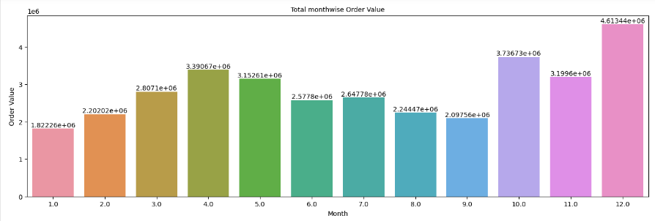

Above chart show best month for sale is December as highest order value came in the same month.

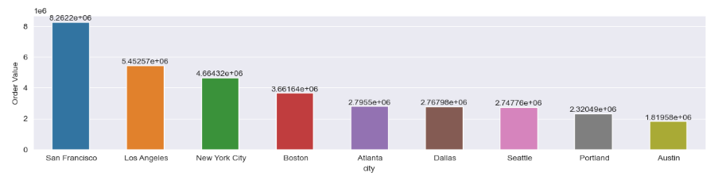

Highest number of sale came from San Francisco, Los Angeles and New York City.

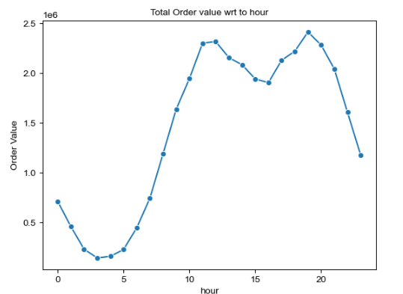

Around 11 am and 7pm is good to start advertising campaign to increase sales.

Also, below products sold most together:

1. Iphone, Lightning Charging Cable
2. Google Phone, USB-C Charging Cable
3. Iphone, Apple Airpods Headphones

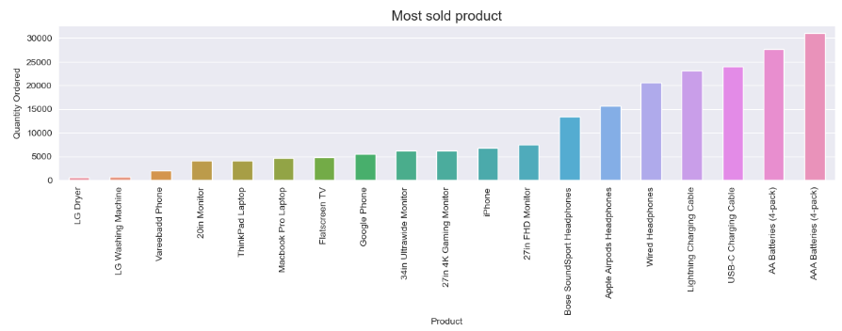

Most sold product is AAA Batteries (4-pack) then AA Batteries (4-pack).

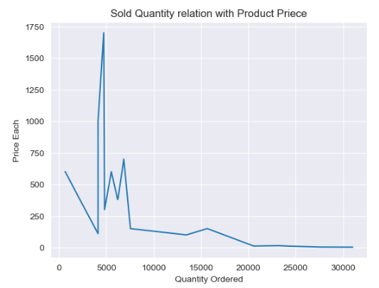

Above chart helps us to understand relation between product price and product sold quantity. Product sold quantity increases as product price reduces.